**350**



**ADW310 Wireless Energy Meter**

**Installation and Use Manual V1.0**

**Acrel Co., Ltd.**

**Declaration**

The copyright is the property of Acrel. Any information in any paragraph or section cannot be extracted, copied or otherwise reproduced or propagated. Otherwise offenders shall take all consequences.

All rights are reserved.

Acrel reserves the right to modify the product specifications herein without notification. Please consult the local agent about the latest specifications before placing a purchase order.

Manual revision record

|  |  |  |  |
| --- | --- | --- | --- |
| Date | Old Version | New Version | Modify the content |
| 2022/8/8 |  | V1.0 | 1.Writing for the first time |

**Catalog**

1 Overview 1

2 Product Model Specification And Features 1

2.1 ADW310 Wireless Energy Meter Naming Rules 1

2.2 ADW310 Wireless Energy Meter Features 1

3 Technical Parameters 2

3.1 Electrical Characteristics 2

3.2 Environmental Conditions 3

4 Dimension and Installing Description( Unit：mm) 3

4.1 Dimension( Unit：mm) 3

4.2 RS485 Communication Terminal, Pulse Output Terminal 4

4.3 Switch Input/Output Terminal 4

4.4 Temperature Measuring Terminal 5

4.5 Wiring Instructions 6

5 Main Features 6

5.1 Measurement Function 6

5.2 Metering Function 6

5.3 Time Sharing Function 7

5.4 Demand Function 7

5.5 Historical Energy Statistics Function 8

5.6 Switch Input And Output Function 8

5.7 Wireless Communication Function 8

6 Communication Instructions 8

6.1 Communication Protocol 8

6.2 MODBUS Communication 9

6.3 Alarm Function Related Settings 15

6.3.1Alarm 1 Related Parameter Register Address Table 15

6.3.2Alarm 2/3 Related Parameter Register Address Table 17

7 Common Troubleshooting 19

7.1 Instrument RS485 Network Communication Failure 19

7.2 Instrument Wireless Communication Failure 20

# 

# 1 Overview

ADW310 wireless energy meter is mainly used to measure the active energy of low-voltage network. It has the advantages of small size, high precision, rich functions, etc., and has many optional communication methods. It can support RS485 communication, Lora, 4G and other wireless communication methods. The current sampling mode of the transformer is convenient for users to install and use in different occasions. It can be flexibly installed in the distribution box to meet the needs of power metering, operation and maintenance supervision or power monitoring for different areas and different loads.

# 2 Product Model Specification And Features

# 2.1 ADW310 Naming Rules

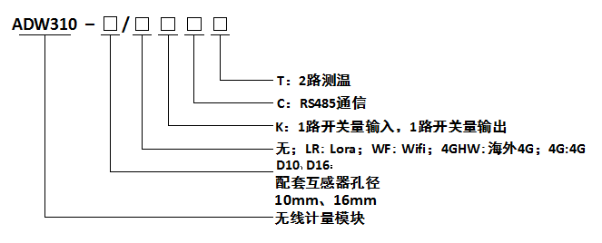

**Diameter Of Matched Current Transformer**

**None: LR:LoRA WF:WIFI 4GHW:4G Overseas Version 4G:Domestic 4G**

**Wireless Metering Module**

**1 Channel DI,1 Channel DO**

**RS485 Communication**

**2 Channels Temperature Monitoring**

# 2.2 ADW310 Features

Table 1 ADW310 Main Function

|  |  |
| --- | --- |
| Function | Description |
| Display | LCD (field type) |
| Energy Metering | Active energy metering (forward, reverse) |
| Electricity Measurement | Voltage,current,power factor, frequency,active power,reactive power, apparent power |
| Pulse Output | Active pulse output |
| Temperature Measurement Function | Two-way temperature measurement (optional T) |
| DI/DO | 1DI, 1DO (optional K) |
| LED Indication | Pulse light indication |
| External Transformer | External split core current transformer |
| Electric Parameter Alarm | Leakage of voltage, overvoltage, Leakage of current, overcurrent, leakage of load, overload, etc. |
| Communication | RS485 interface (optional C) |
| 470MHz wireless transmission (optional LR) |
| 4G wireless transmission (optional 4G) |
|  | WIFI wireless communication (optional WF) |

# 3 Technical Parameters

# 3.1 Electrical Characteristics

Table 2 ADW310 Electrical Characteristics

|  |  |  |
| --- | --- | --- |
| Voltage Input | Rated Voltage | 220V |
| Reference Frequency | 50Hz |
| Power Consumption | Each phase<0.5VA |
| Current Input | Input Current | AC 20(100)A |
| Starting Current | 1‰Ib(0.5S class)，4‰Ib(1 class) |
| Power Consumption | Each phase<1VA |
| Auxiliary Power | Voltage Supply | AC 85~265V |
| Power Consumption | <2W |
| Measuring Performance | Standards | GB/T17215.322-2008，GB/T17215.321-2008 |
| Compliant  Active Energy Accuracy | Class 1 |
| Temperature Accuracy | ±2℃ |
| Pulse | Pulse Width | 80±20ms |
| Pulse Constant | 1600imp/kWh |
| Communication | Wirelese | 470MHz wireless transmission, transmission distance in open space: 1km; 4G |
| Interface | RS485(A、B) |
| Medium | Shielded Twisted Pair |
| Protocol | MODBUS-RTU、DL/T 645-07 |

# 3.2 Environmental Conditions

Table 3 ADW310 Environment Conditions

|  |  |  |
| --- | --- | --- |
| Temperature Range | Operating Temperature | -25℃~55℃ |
| Storage Temperature | -40℃~70℃ |
| Humidity | | ≤95%(no condensation) |
| Altitude | | <2000m |

# 4 Dimension and Installing Description( Unit：mm)

# 4.1 Dimension( Unit：mm)

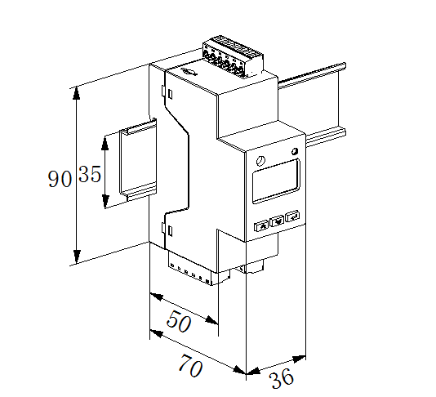

Figure 1 ADW310 Size Figure

Supporting CT Dimensions

Table 5 Specifications and Dimensions of Supporting Transformers

|  |  |  |  |  |  |  |  |  |
| --- | --- | --- | --- | --- | --- | --- | --- | --- |
| Specification | Dimensions (mm) | | | | | Perforation size (mm) | | Tolerance (mm) |
| W | H | D | M | N | Φ1 | Φ2 |
| AKH-0.66/K-∅10N | 27 | 44 | 32 | 25 | 36 | 10 | 9 | ±1 |
| AKH-0.66/K-∅16N | 31 | 50 | 36 | 27 | 42 | 16 | 17 |

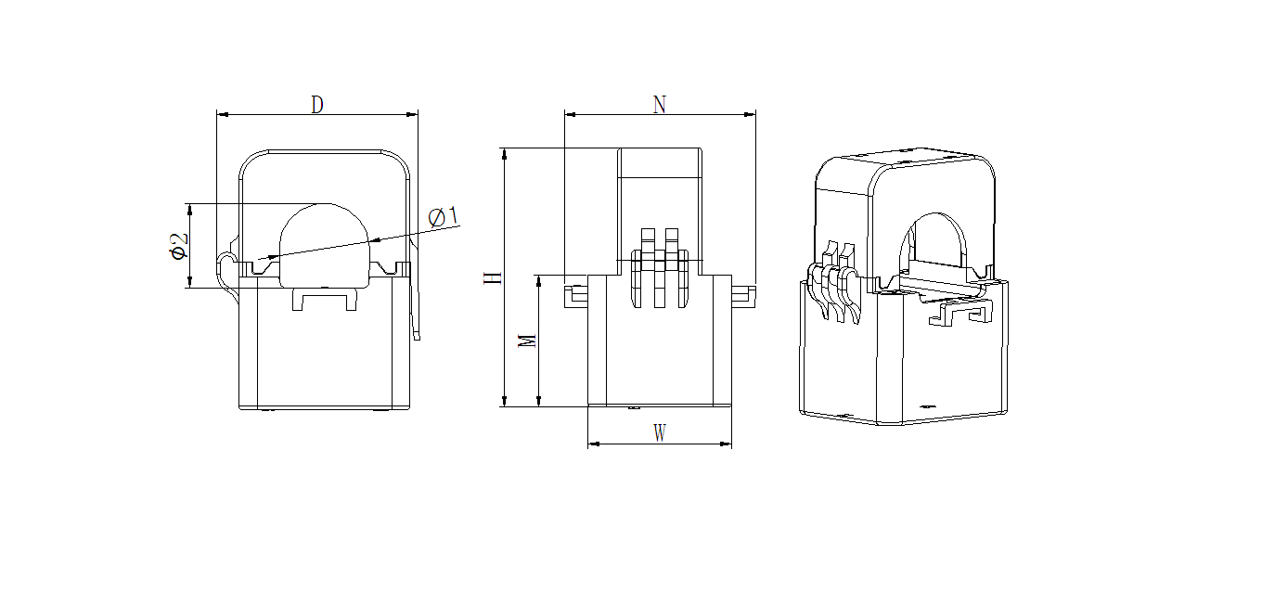

Dimension Figure of Matched Current Transformer

# 4.2 Communication Terminal, Pulse Output Terminal

# 

Communication Interface Pulse Port

# 4.3 Switch Input/output Terminal

The switch input is the switch signal input method, the instrument is equipped with +12V working power supply, no external power supply is required. When the external connection is turned on or off, the on or off information is collected through the instrument switch input module and displayed locally by the instrument. The switch input can not only collect and display the local switch information, but also realize the remote transmission function through the RS485 of the instrument, that is, the "remote signal" function.

Switch output is relay output, which can realize "remote control" and alarm output.

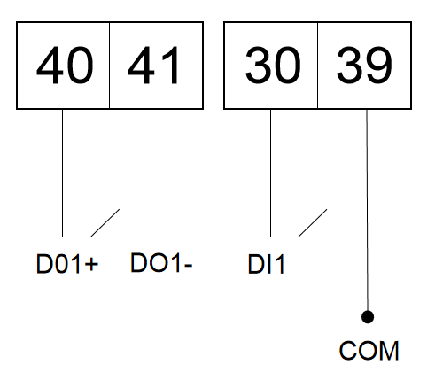

Switch input and output

# 4.4 Temperature Measuring Terminal

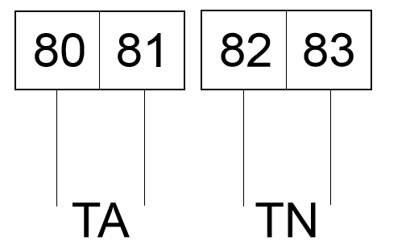

Temperature Input

# 4.5 Wiring Instructions

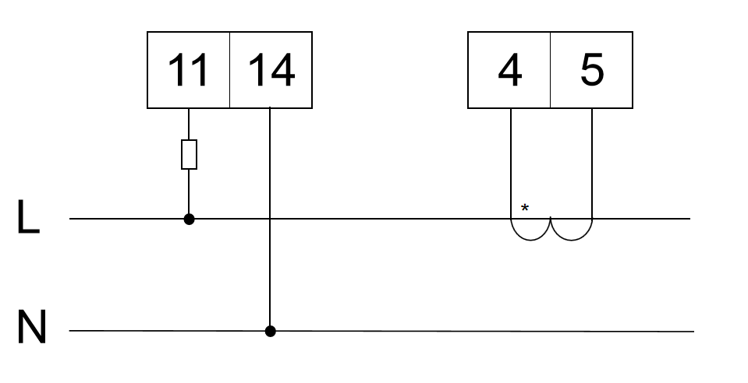

# 5 Main Features

# 5.1 Measurement Function

It can measure all power parameters including voltage U, current I, active power P, reactive power Q, apparent power S, power factor PF, phase angle Φ between voltage and current, frequency F. Among them, the voltage U has 1 decimal place, the frequency F has 2 decimal places, the current I has 3 decimal places, the power P has 4 decimal places, and the phase angle Φ has 2 decimal places.

Such as: U = 220.1V, f = 49.98HZ, I = 1.999A, P = 0.2199KW, Φ= 60.00°.

Support 2-way temperature measurement, temperature measurement range: -40 ~ 99 °C,accuracy ±2 °C

# 5.2 Metering Function

It can measure the current combined active energy, forward active energy, reverse active energy, inductive reactive energy, capacitive reactive energy, and apparent energy.

# 5.3 Time Sharing Function

Two sets of timetables, one year can be divided into 4 time zones, each set of timetables can set 12 daily time periods, 4 rates (F1, F2, F3, F4 are peaks and valleys). The basic idea of time-of-use billing is to use electric energy as a commodity, using economic leverage, the electricity price is high during the peak period of electricity consumption, and the electricity price is low when the valley is low, so as to cut the peak and fill the valley, improve the quality of electricity consumption, and improve the overall economic benefits.

# 5.4 Demand Function

The concepts related to demand are as follows：

|  |  |
| --- | --- |
| Demand | The average power measured during the demand period is called demand |
| Maximum Demand | The maximum demand in a specified time zone is called the maximum demand |
| Slip Time | From any moment, the method of recursively measuring demand according to the time less than the demand period, the measured demand is called slip demand. The recursive time is called slip time |
| Demand Cycle | The time interval at which the average power is continuously measured is equal, also called the window time |

The default demand period is 15 minutes and the slip time is 1 minute.

It can measure 8 kinds of maximum demands, namely A/B/C three-phase current, forward active power, reverse active power, inductive reactive power, capacitive reactive power, apparent power maximum demand and the time when the maximum demand occurs.

Displays 8 real-time demands, namely A/B/C three-phase current, forward active power, reverse active power, inductive reactive power, capacitive reactive power, and apparent power demand.

# 5.5 Historical Energy Statistics Function

It can count the historical electric energy in December (including 4 quadrants and electric energy at various rates)

# 5.6 Switch Input And Output Function

There are 1 switch output, 1 switch input, and the switch output is relay output, which can realize "remote control" and alarm output. The switch input can not only collect and display the local switch information, but also realize the remote transmission function through the RS485 of the instrument, that is, the "remote signal" function.

# 5.7 Wireless Communication Function

ADW310 supports 470MHz LORA communication and 4G communication. The specific agreement on 4G communication can be obtained by contacting the relevant personnel of our company.

# 6 Communication Description

# 6.1 Comunication Protocol

This instrument adopts MODBUS-RTU protocol or DL/T645 protocol. For the specific protocol format, please refer to the relevant protocol standards, which will not be repeated here.

# 6.2 MODBUS Communication

When using Modbus protocol for communication, the function code of the read data command is 03H, and the function code of the write data command is 10H.

The specific register address table is as follows:

|  |  |  |  |  |
| --- | --- | --- | --- | --- |
| Initial Address  (hexadecimal) | Data Item Name | Length (Byte) | R/W | Remark |
| 1000H | Communication Adress | 2 | R/W | 1～247 |
| 1001H | Baud rate | 2 | R/W | 1：1200bps  2：2400bps  3：4800bps  4：9600bps  5：19200bps  6：38400bps |
| 1002H | 1 Check Digit 1 | 2 | R/W | low byte  0: no verification  1: odd parity  2: Even parity  high byte  0:1 stop bit  1: 1.5 stop bit  2:2 stop bits |
| 1003H-1005H | Reserved | | | |
| 1006H | 645 address | 6 | R/W | BCD code high order first |
| 1009H | Serial Number | 14 | R/W | 14 ASCII codes |
| 1010H | Wire | 2 | R/W | 0:3P4L 1:3P3L |
| 1011H | Voltage secondary rating | 2 | R/W | one decimal place V |
| 1012H | Current secondary rating | 2 | R/W | two decimal places A |
| 1013H-101CH | Reserved | | | |
| 101DH | Password | 2 | R/W | 1-9999 |
| 101EH | Pulse constant | 2 | R/W | Default 1600 |
| 101FH | Voltage shield | 2 | R/W | 0~655.35% |
| 1020H | Current shield | 2 | R/W | 0~655.35% |
| 1021H-1025H | Reserved | | | |
| 1026H | Demand Cycle | 2 | R/W | Unit min (1-30) |
| 1027H-102DH | Reserved | | | |
| 102EH | Backlight time | 2 | R/W | 0: always on 1: 1min 2:2min |
| 102FH | Time | 10 | R/W | Year,  Month Day,  week, hour,  minutes, seconds,  millisecond |
| 1034H-1035H | Reserved | | | |
| 1036H | DO status | 2 | R/W | Bit0:DO1 Bit1: DO2...  0: open  1: closed |
| 1037H | DI status | 2 | R | Bit0:DI1 Bit1: DI2...  0: open  1: closed |
| 1038H | First time zone timetable number  First time zone start month, first time zone day  Second time zone timetable number  Second time zone start month, second time zone day  Third time zone timetable number  3rd time zone start month, 3rd time zone day  Fourth time zone timetable number  4th time zone start month, 4th time zone day  Fifth time zone timetable number  Fifth time zone start month, fifth time zone day  Sixth time zone timetable number  6th time zone start month, 6th time zone day  Seventh time zone timetable number  7th time zone start month, 7th time zone day  Eighth time zone timetable number  Eighth time zone start month, eighth time zone day | 12 | R/W | Timetable No.:  period 1,  period 2,  period 3,  period 4,  Start month: 1-12  Start day: 1-31 |
| 1044H | The first set of timetables,  Each period occupies three bytes,  Rate, start hour, start minute |  | R/W | Rate:0  1 Sharp，2 Peak  3 Flat，4 Valley  Start Hour：0-23  Start Minute：1-59 |
| 1059H | The second set of timetables,  Each period occupies three bytes,  Rate, start hour, start minute |  | R/W | Same as the first set of timetables |
| 106EH | The third set of timetables,  Each period occupies three bytes,  Rate, start hour, start minute |  | R/W | Same as the first set of timetables |
| 1083H | The forth set of timetables,  Each period occupies three bytes,  Rate, start hour, start minute |  | R/W | Same as the first set of timetables |
| 1098H | Voltage Ratio | 4 | R/W | Int |
| 109AH | Current Ratio | 4 | R/W | Int |
| 109CH-109FH | Reserved | | | |

|  |  |  |  |  |
| --- | --- | --- | --- | --- |
| 2000H | Voltage | 4 | R | 1 decimal place  unit:V  If the value is U=2200, PT=1;  U=U*PT=2200*0.1*1=220.0V |
| 2001H-200BH | Reserved | | | |
| 200CH | Current | 4 | R | 2 decimal place  If the value is I=200，CT=10;  I=I*CT=200*0.01*10=20A |
| 200DH-2013H | Reserved | | | |
| 2014H | Active power | 4 | R | Int With symbol  Unit:kW  3 decimal place  If the value is 11720，PT=10,CT=10;  then value = value*PT*CT=  11720*0.001*10*10=1172.0kW |
| 2016H-201BH | Reserved | | | |
| 201CH | reactive power | 4 | R | Int With symbol  Unit:kVar  3 decimal place  Analyze the same active power |
| 201EH-2023H | Reserved | | | |
| 2024H | Inspecting power | 4 | R | Int  Unit:kVar  3 decimal place  Analyze the same active power |
| 2026H-202BH | Reserved | | | |
| 202CH | Power factor | 4 | R | Int  3 decimal place  If the value is 999  then the value=999*0.001=0.999 |
| 202EH-2033H | Reserved | | | |
| 2034H | Frequency | 4 | R | Int  2 decimal place  If the value is 5000,  Then the value=5000*0.01=50.00H |
| 2036H- | Reserved | | | |
| 2058H | temperature 1 | 4 | R | Int WIth symbol  Unit:0.1℃ |
| 205AH | temperature 2 | 4 | R | ℃  Int WIth symbol  Unit:0.1℃ |

|  |  |  |  |  |
| --- | --- | --- | --- | --- |
| 3000H | Secondary value of total active energy | 4 | R/W | Two decimal places, Kwh |
| 3002H | Secondary value of forward active energy | 4 | R/W | Two decimal places, Kwh |
| 3004H | Secondary value of reverse active energy | 4 | R/W | Two decimal places, Kwh |
| 3006H | Secondary value of total reactive energy | 4 | R/W | Two decimal places, Kvarh |
| 3008H | Secondary value of forward reactive energy | 4 | R/W | Two decimal places, Kvarh |
| 300AH | Secondary value of reverse reactive energy | 4 | R/W | Two decimal places, Kvarh |
| 300CH | Reserved | | | |
| 300EH | Total active energy sharp secondary value | 4 | R/W | Int,Unit:kWh  2 decimal place  If the value is 120201, PT=10, CT=10;  Then value=value*PT*CT=  120201*0.01*10*10=12020 |
| 3010H | Total active energy peak secondary value | 4 | R/W | Int,Unit:kWh  2 decimal place  If the value is 120201, PT=10, CT=10;  Then value=value*PT*CT=  120201*0.01*10*10=12020 |
| 3012H | Total active energy level flat value | 4 | R/W | Int,Unit:kWh  2 decimal place  If the value is 120201, PT=10, CT=10;  Then value=value*PT*CT=  120201*0.01*10*10=12020 |
| 3014H | Secondary value of total active energy valley | 4 | R/W | Int,Unit:kWh  2 decimal place  If the value is 120201, PT=10, CT=10;  Then value=value*PT*CT=  120201*0.01*10*10=12020 |
| 3016H | Forward active energy sharp secondary value | 4 | R/W | Int,Unit:kWh  2 decimal place  If the value is 120201, PT=10, CT=10;  Then value=value*PT*CT=  120201*0.01*10*10=12020 |
| 3018H | Forward active energy peak secondary value | 4 | R/W | Int,Unit:kWh  2 decimal place  If the value is 120201, PT=10, CT=10;  Then value=value*PT*CT=  120201*0.01*10*10=12020 |
| 301AH | Forward active energy level flat value | 4 | R/W | Int,Unit:kWh  2 decimal place  If the value is 120201, PT=10, CT=10;  Then value=value*PT*CT=  120201*0.01*10*10=12020 |
| 301CH | Forward active energy valley secondary value | 4 | R/W | Int,Unit:kWh  2 decimal place  If the value is 120201, PT=10, CT=10;  Then value=value*PT*CT=  120201*0.01*10*10=12020 |
| 301EH | Reverse active energy sharp secondary value | 4 | R/W | Int,Unit:kWh  2 decimal place  If the value is 120201, PT=10, CT=10;  Then value=value*PT*CT=  120201*0.01*10*10=12020 |
| 3020H | Reverse active energy peak secondary value | 4 | R/W | Int,Unit:kWh  2 decimal place  If the value is 120201, PT=10, CT=10;  Then value=value*PT*CT=  120201*0.01*10*10=12020 |
| 3022H | Reverse active energy valley secondary value | 4 | R/W | Int,Unit:kWh  2 decimal place  If the value is 120201, PT=10, CT=10;  Then value=value*PT*CT=  120201*0.01*10*10=12020 |
| 3024H | Forward reactive energy sharp secondary value | 4 | R/W | Int,Unit:kWh  2 decimal place  If the value is 120201, PT=10, CT=10;  Then value=value*PT*CT=  120201*0.01*10*10=12020 |
| 3026H | Forward reactive energy peak secondary value | 4 | R/W | Int,Unit:kWh  2 decimal place  If the value is 120201, PT=10, CT=10;  Then value=value*PT*CT=  120201*0.01*10*10=12020 |
| 3028H | Forward reactive energy flat secondary value | 4 | R/W | Int,Unit:kWh  2 decimal place  If the value is 120201, PT=10, CT=10;  Then value=value*PT*CT=  120201*0.01*10*10=12020 |
| 302AH | Forward reactive energy valley secondary value | 4 | R/W | Int,Unit:kWh  2 decimal place  If the value is 120201, PT=10, CT=10;  Then value=value*PT*CT=  120201*0.01*10*10=12020 |
| 302CH | Reverse reactive energy sharp secondary value  Reverse reactive energy peak secondary value | 4 | R/W | Int,Unit:kWh  2 decimal place  If the value is 120201, PT=10, CT=10;  Then value=value*PT*CT=  120201*0.01*10*10=12020 |
| 302EH | Reverse reactive energy flat secondary value | 4 | R/W | Int,Unit:kWh  2 decimal place  If the value is 120201, PT=10, CT=10;  Then value=value*PT*CT=  120201*0.01*10*10=12020 |
| 3030H | Reverse reactive energy valley secondary value | 4 | R/W | Int,Unit:kWh  2 decimal place  If the value is 120201, PT=10, CT=10;  Then value=value*PT*CT=  120201*0.01*10*10=12020 |
| 3032H- | Reserved | | | |

|  |  |  |  |  |
| --- | --- | --- | --- | --- |
| 4006H | Total active power real-time demand | 4 | R | Int,Unit:kW  3 decimal place |
| 400CH | Total forward active power real-time demand | 4 | R | Int,Unit:kW  3 decimal place |
| 400EH | Total reverse active power real-time demand | 4 | R | Int,Unit:kW  3 decimal place |
| 4010H | Total forward reactive power real-time demand | 4 | R | Int,Unit:kW  3 decimal place |
| 4012H | Total reverse reactive power real-time demand | 4 | R | Int,Unit:kW  3 decimal place |
| 4014H- | Reserved | | | |

|  |  |
| --- | --- |
| 01D0H-01EBH | Alarm 1 related data, see chapter 6.3.1 for details |
| 0216H-0249H | Alarm 2, alarm 3 related data, see chapter 6.3.2 for details |
| 0268H-0169H | Alarm 2, Alarm 3 alarm status, see chapter 6.3.2 for details |

# 6.3 Alarm Function Related Settings

# 6.3.1 Alarm 1 Related Parameter Register Address Table

|  |  |  |  |  |  |
| --- | --- | --- | --- | --- | --- |
| Start Address (Hexadecimal) | Initial Address  (decimal) | Data Item Name | Length (Bytes) | R/W | Remark |
| 01EBH | 491 | Alarm 1 state | 2 | R | bit0: Over voltage alarm  bit1: under voltage alarm  Bit2: Overcurrent alarm  Bit3: undercurrent alarm  Bit4: Over power alarm  Bit5: Under power alarm  Bit6: Whether DO1 alarm output  bit7: Whether DO2 alarm output  Bit8:  Bit9:  Bit10:  Bit11:  Bit12:  Bit13:  Bit14:  Bit15: Power failure report |
| 01DOH | 464 | Alarm 1 enable bit | 2 | R/W | Bit0: Overvoltage alarm enable bit  Bit1: Undervoltage alarm enable bit  Bit2: Overcurrent alarm enable bit  Bit3: Undercurrent alarm enable bit  Bit4: Over power alarm enable bit  Bit5: Under-power alarm enable bit  Bit6: Whether DO1 alarm output  Bit7: Whether DO2 alarm output  Bit8:  Bit9:  Bit10:  Bit11:  Bit12:  Bit13:  Bit14:  Bit15: Power-off report enable bit |
| 01D1H | 465 | Over voltage alarm threshold | 2 | R/W | Int,Unit:0.1V |
| 01D2H | 466 | Over voltage alarm delay | 2 | R/W | Int,Unit:0.1S |
| 01D3H | 467 | Undervoltage alarm threshold | 2 | R/W | Int,Unit:0.1V |
| 01D4H | 468 | Undervoltage alarm delay | 2 | R/W | Int,Unit:0..01S |
| 01D5H | 469 | Overcurrent Alarm Threshold | 2 | R/W | Int,Unit:0..01A |
| 01D6H | 470 | Overcurrent Alarm Delay | 2 | R/W | Int,Unit:0..01S |
| 01D7H | 471 | Undercurrent alarm threshold | 2 | R/W | Int,Unit:0..01A |
| 01D8H | 472 | Undercurrent alarm delay | 2 | R/W | Int,Unit:0..01S |
| 01D9H | 473 | Over power alarm threshold | 2 | R/W | Int,Unit:0..001kw |
| 01DAH | 474 | Over power alarm delay | 2 | R/W | Int,Unit:0..01S |
| 01DBH | 475 | Under power alarm threshold | 2 | R/W | Int,Unit:0..001kw |
| 01DCH | 476 | Under power alarm delay | 2 | R/W | Int,Unit:0..01S |
| 01DDH | 477 | DI1 initial state | 2 | R/W | 0: Normally open  1: Normally closed |
| 01DEH | 478 | DI1 programming | 2 | R/W | 0: Do not associate with DO  1: Associate DO1  2: Associate DO2 |
| 01E5H | 485 | DO1 output mode | 2 | R/W | 0: level  1: Pulse |
| 01E6H | 486 | DO1 related content | 2 | R/W | 0: Normal DO  1: total failure  2: Total fault +DI1+DI2 3: DI1  4:DI2  5:DI1+DI2 |
| 01E7H | 487 | DO1 output pulse width | 2 | R/W | 0:none  1:1S  2:2S  3:3S  4:4S  5:5S |

# 6.3.2 Alarm 2, Alarm 3 Related Parameter Register Address Table

|  |  |  |  |  |  |
| --- | --- | --- | --- | --- | --- |
| Start Address (Hexadecimal) | Initial Address  (Decimal) | Data Item Name | Length (bytes) | R/W | Remark |
| 0216H | 534 | Alarm 2 enable bit | 2 | R/W | Bit0: Low power factor alarm enable bit  Bit1:  Bit2:  Bit3:  Bit4:  The first channel temperature is too high alarm enable bit  Bit5:  Bit6:  bit7:  The second channel over temperature alarm enable bit  Bit8:  Bit9:  Bit10:  Bit11:  Bit12:  Bit13:  Bit14:  Bit15: |
| 0268H | 616 | Alarm 2 Alarm status | 2 | R | Corresponding to alarm 2 enable bit |
| 0217H | 535 | Alarm 3 enable bit | 2 | R/W | Bit0: Current positive active power demand is too high alarm enable bit  Bit1: Current reverse active power demand high alarm enable bit  Bit2: Current high reactive power demand alarm enable bit  Bit3: Current reverse reactive power demand high alarm enable bit  Bit4: Current apparent demand high alarm enable bit  Bit5-Bit15:Reserve |
| 0269H | 617 | Alarm 3 alarm status | 2 | R | Corresponding to alarm 3 enable bit |
| 0218H | 536 | High power factor alarm threshold | 2 | R/W | Int,Unit:0..001 |
| 0219H | 537 | Power factor high alarm delay  T | 2 | R/W | Int,Unit:0..01S |
| 0220H | 544 | he first circuit temperature is too high alarm threshold | 2 | R/W | Int with symbol,Unit:0.1℃ |
| 0221H | 545 | The first circuit over temperature alarm delay | 2 | R/W | Int ,Unit:0.01S |
| 0222H | 550 | The second circuit temperature is too high alarm threshold | 2 | R/W | Int with symbol,Unit:0.1℃ |
| 0223H | 551 | The second circuit over temperature alarm delay | 2 | R/W | Int ,Unit:0.01S |
| 0237H | 567 | Current unbalance too high alarm delay | 2 | R/W | Int ,Unit:0.01S |
| 0238H | 568 | The current forward active power demand is too high alarm threshold | 4 | R/W | Int,Unit:kW  3 decimal place |
| 023AH | 570 | Current reverse active power demand is too high alarm delay | 2 | R/W | Int ,Unit:0.01S |
| 023BH | 571 | The current forward active power demand is too high alarm threshold | 4 | R/W | Int,Unit:kW  3 decimal place |
| 023DH | 573 | Current reverse active power demand is too high alarm delay | 2 | R/W | Int ,Unit:0.01S |
| 023EH | 574 | The current forward reactive power demand is too high alarm threshold | 4 | R/W | Int,Unit:Kvar  3 decimal place |
| 0240H | 576 | The current forward reactive power demand is too high alarm delay | 2 | R/W | Int ,Unit:0.01S |
| 0241H | 577 | The current reverse reactive power demand is too high alarm threshold | 4 | R/W | Int,Unit:Kvar  3 decimal place |
| 0243H | 579 | The current reverse reactive power demand is too high alarm delay | 2 | R/W | Int ,Unit:0.01S |
| 0247H | 583 | Current apparent demand high alarm threshold | 4 | R/W | Int,Unit:KVA  3 decimal place |
| 0249H | 585 | Current apparent demand high alarm delay | 2 | R/W | Int ,Unit:0.01S |

# 7 Common Troubleshooting

# 7.1 Energy Meter RS485 Network Communication Failure

Troubleshooting suggestion: Please confirm whether the RS485 wiring is loose, the AB connection is reversed, etc., and then press the button to check whether the general selection parameters in the table, such as address, baud rate, check digit, etc., are set correctly

# 7.2 Energy Meter Wireless Communication Failure

Troubleshooting suggestion: Please use the USB to 485 serial cable to connect to the RS485 interface of the instrument first, read the parameters in the meter through communication, and confirm whether the parameters in the meter are the same as the wireless configuration of the upper master station (channel and spreading factor). If they are different, please modify The wireless parameters of the instrument are consistent with the main station and then re-test; if they are the same, it may be that the distance between instrument and the main station are too long or the on-site interference is serious. At this time, you can try to use an external suction cup antenna, or consider adding a wireless main station nearby. Test again.